Lab 1 – CSW 430 – Mobile Application Development
Question 1:
Finishing creating a repository. https://github.com/chaunhattang/CSW430.git
Link: https://github.com/chaunhattang/CSW430-Mobile-Application-Development.git
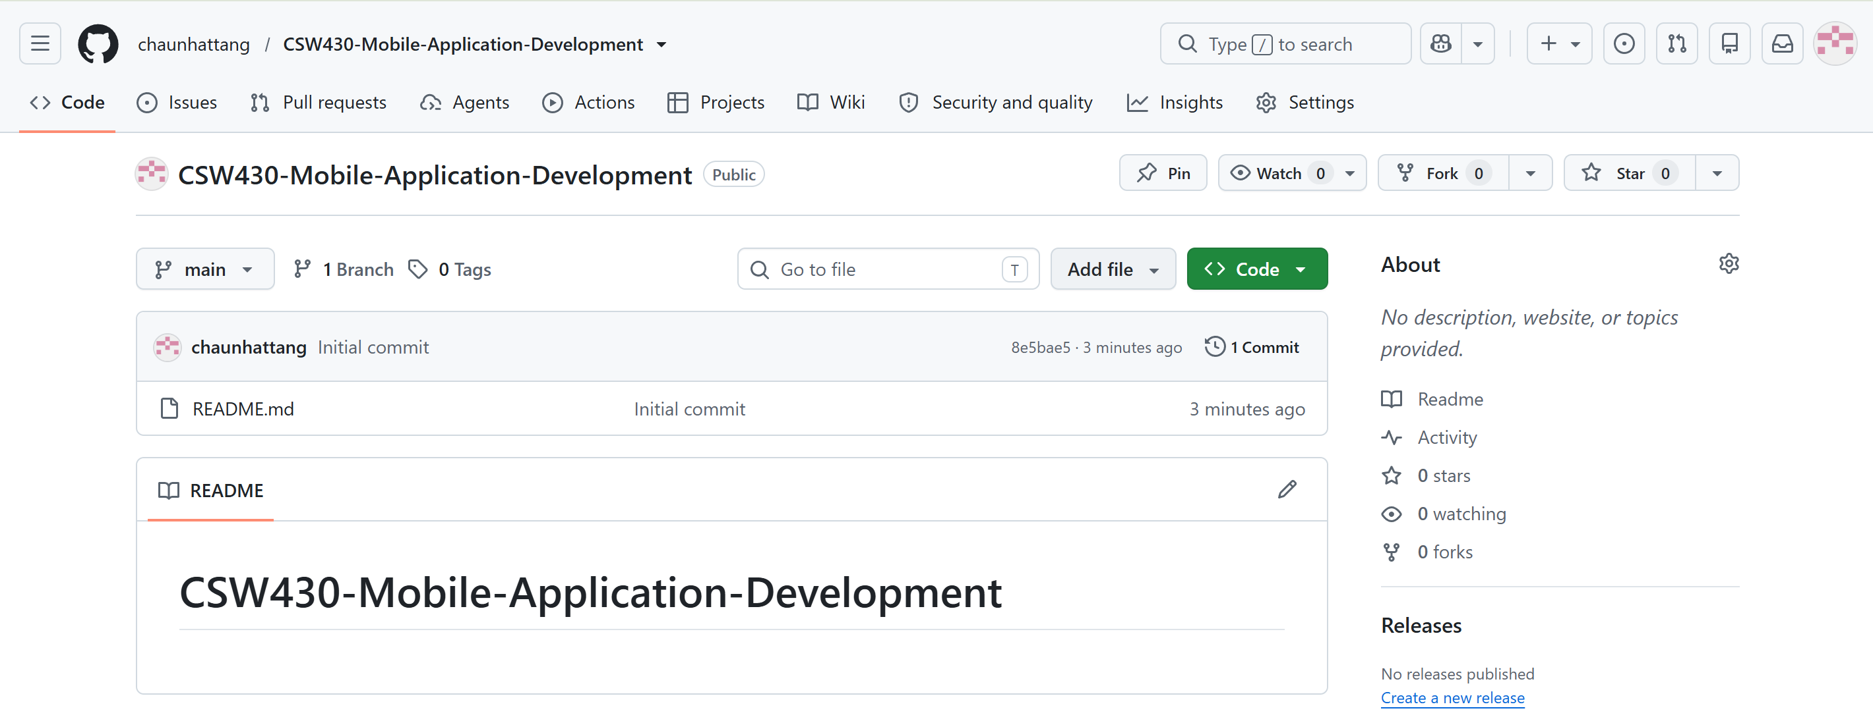
Question 2:
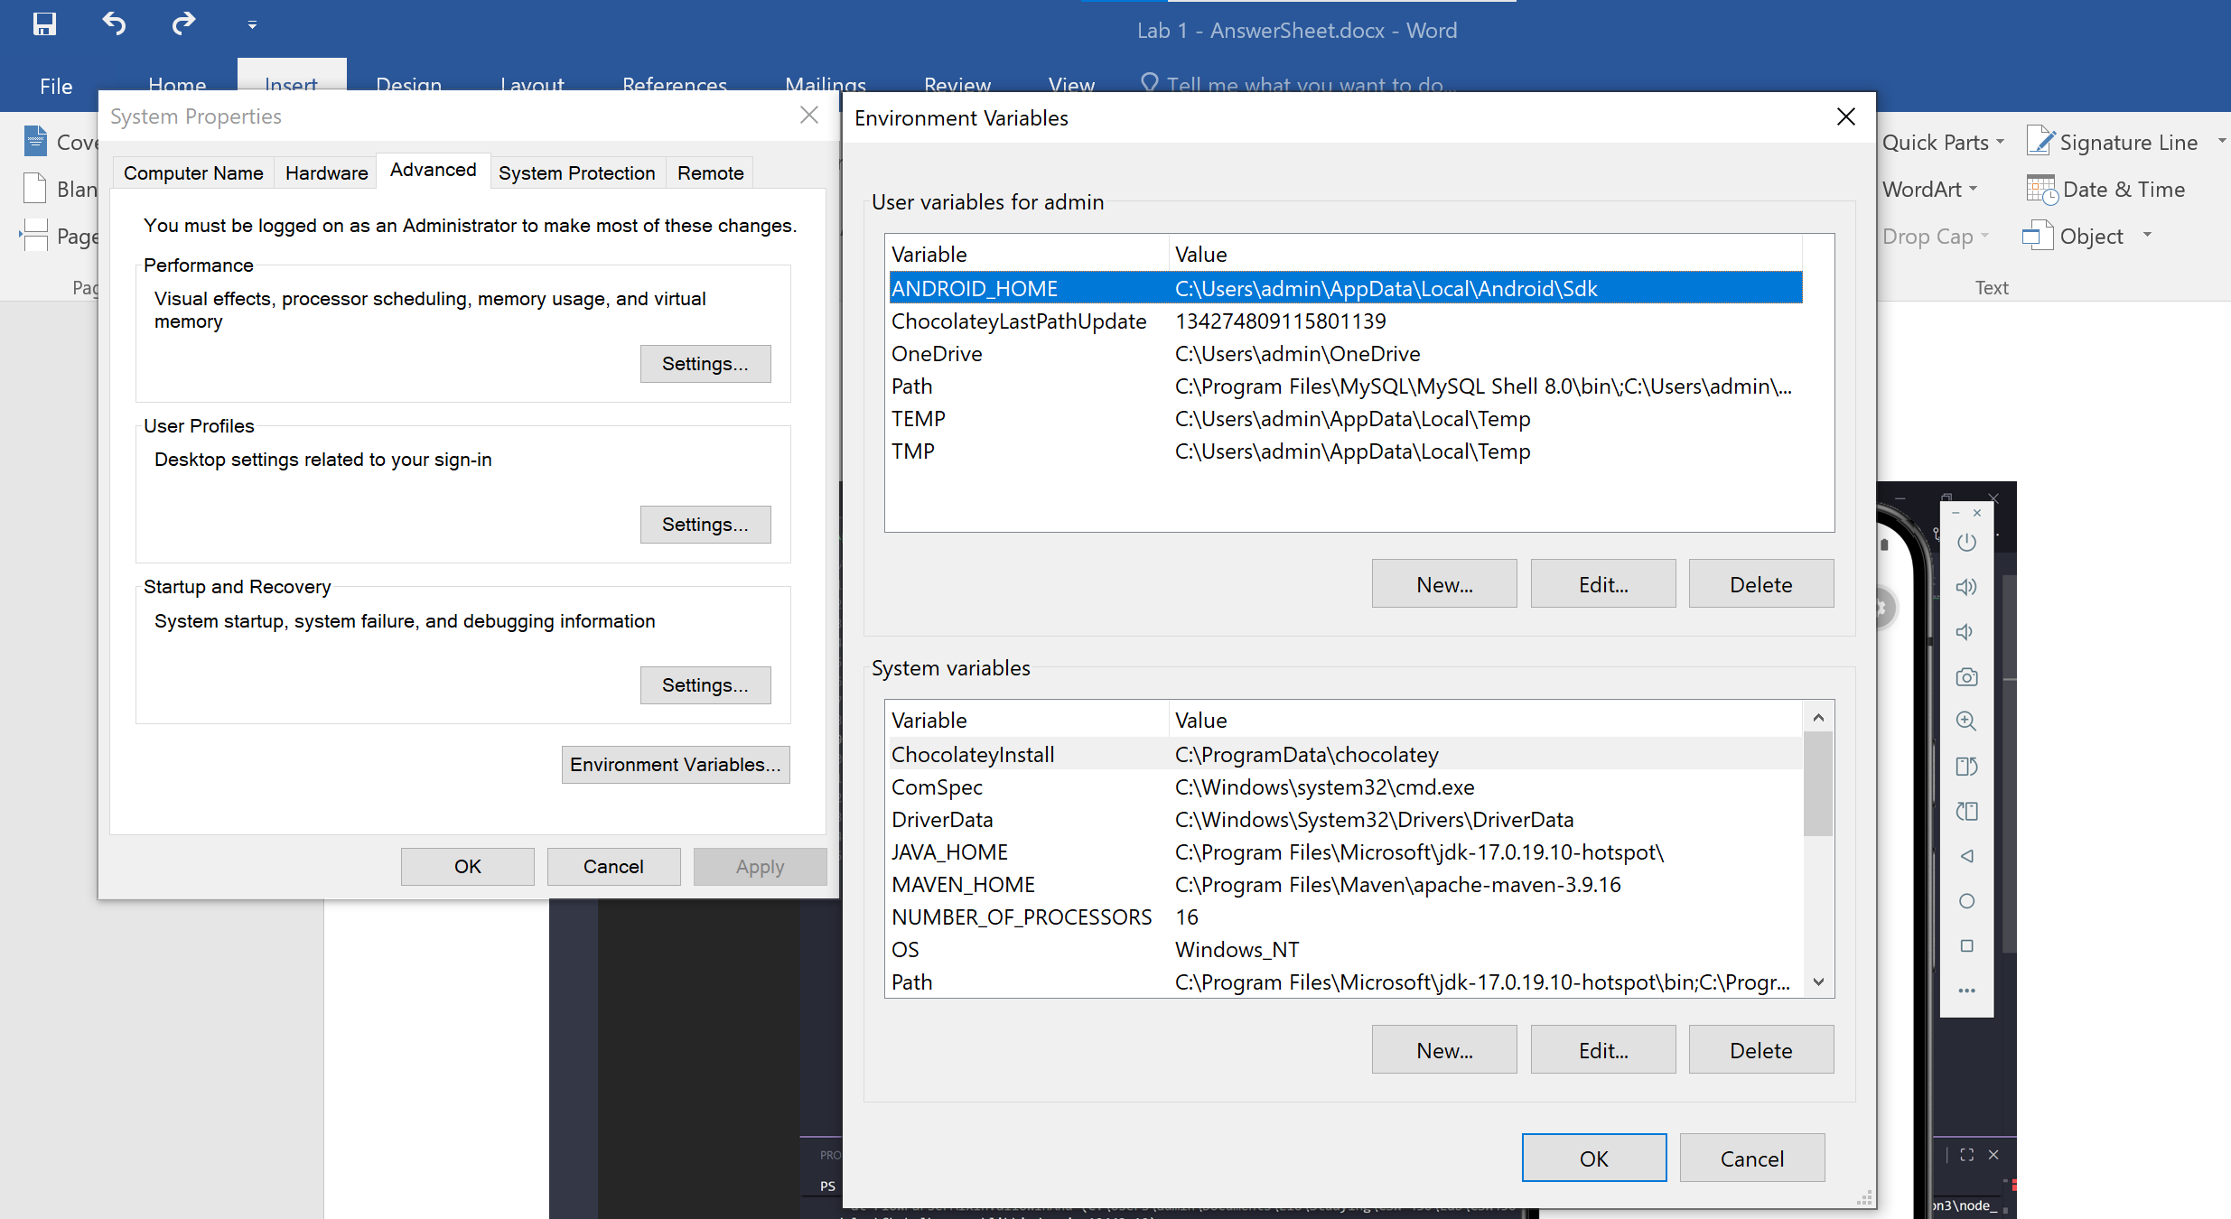

Question 3:
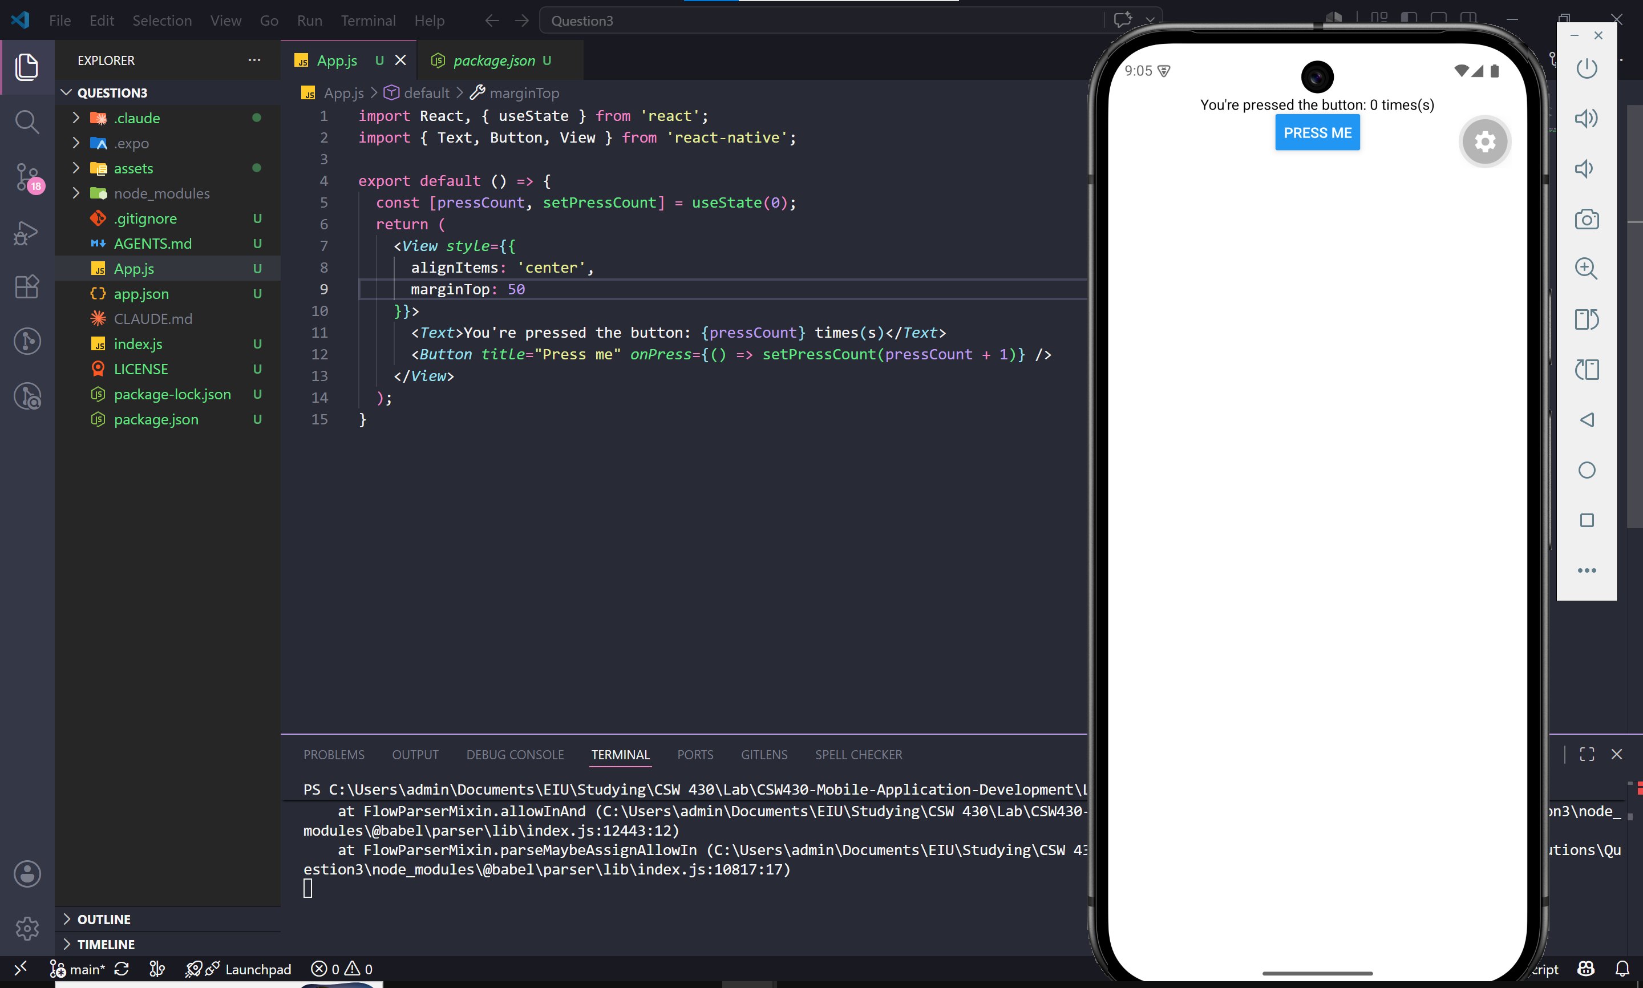
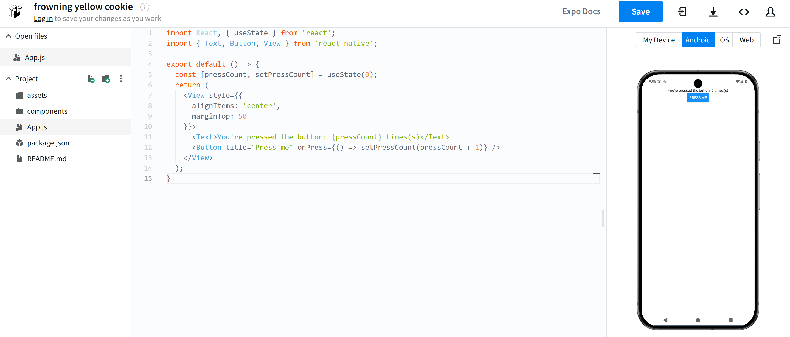

Question 4
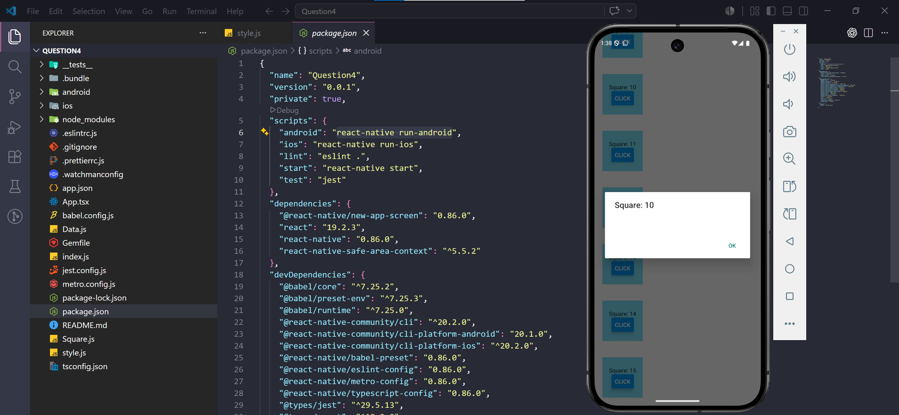
Question 5
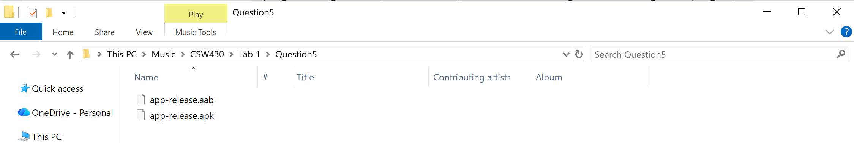

Question 6
